**Business Justification**

**for the development of new ISO 20022 financial repository items**

*Note: the purpose of this document is to give guidelines to organisations that want to develop new candidate ISO 20022 message definitions. Such requests are subject to the approval of a business justification by the ISO 20022 Registration Management Group (RMG). Please consult the iso20022.org website for additional details on* [*the registration process*](http://www.iso20022.org/development.page)*. The business justification must include the following captions, as described. Business justifications are to be sent via e-mail to* [*iso20022ra@iso20022.org*](mailto:iso20022ra@iso20022.org)

1. **Name of the request:**

Agreement of Terms for payments and cover requests.

1. **Submitting organisation(s):**

The Mojaloop Foundation

*A.2 Contact person:*

Michael Richards. [Michael.Richards@infitx.com](mailto:Michael.Richards@infitx.com), +44 7785 360009

*A.3 Sponsors*:

1) Africanenda

2) Comesa Business Council

Contact: Dr. Jonathan Pinifolo, jpinifolo@comesabusinesscouncil.org

1. **Scope of the new development:**

This Business Justification is intended to support the efficient processing of FI-to-FI customer credit transfers (pacs.008) and financial institution credit transfers (pacs.009) in environments where systems are processing large numbers of low-value transfers. By “large numbers” we mean a performance objective of processing 1000 financial transactions per second; by “low-value” we mean an average transfer size of the equivalent of 1 USD in local currency.

In any payment context, the cost of manually managing payment exceptions is considerable, and is to be avoided where possible. This is particularly acute with low-value transfers, since the typical cost of remediating a failed payment is orthogonal to the value of the payment. Transfers with these characteristics cannot afford the cost of remediating payments when those payments have already caused funds to be reserved or committed by participants in the transfer. It is also clear from surveys that most of the causes of failure in payments are simple misattributions of identifiers.

A survey based on material collected in 2021 by LexisNexis[1] concluded that the average annual cost of failed payments (defined as payments that were rejected by a participant in the payment chain, and therefore excluding failures due to communications breakdowns) was $360k for banks, $220k for non-bank financial institutions, and $200k for corporates. The causes of these failures were broken down as shown below:

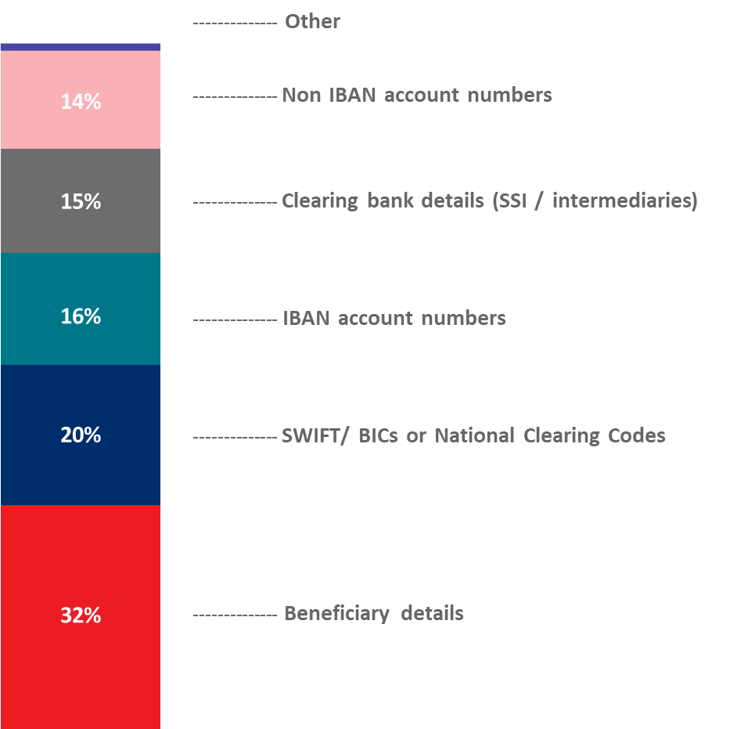

The same survey suggests that, at present, approximately 14% of cross-border payments incur a remediation charge, and that the average amount of that charge is USD 12. This doesn’t sound like a great deal: if the remediation charge were averaged over all cross-border payments, then it would be only $1.68 per payment. However, when we put this against the FSB objective of restricting the costs of cross-border payments to 3%, and eventually to 1%, of the payment amount, the story looks very different. If costs were restricted to 3% of payment amount, then all payments of less than $56 would be unprofitable; at 1% the break-even point rises to $168: and this assumes that the costs of remediation are the only costs associated with a payment, which we know is not the case.

If these errors could be identified and fixed before any of the participants in the transfer has committed funds on the expectation that the transfer will succeed, then the cost of remediation can be transferred from the Financial Institutions participating in the payment to the customers. In particular, if the debtor customer can see a clear statement of who is being paid, how much will be debited from their account and how much their beneficiary’s account will be credited, and give their explicit approval to the transfer before execution is initiated, our experience is that the need for remediation in the payments space plummets.

In addition to this, funds are reserved to cover debtor obligations arising from the payment. For domestic payments, these funds will be reserved against the originating customer’s account; for payments which also require currency conversion or other forms of cover, funds will also be reserved against the debtor FI’s account, and perhaps against other intermediaries’ accounts as well. It is important for small and large payments that account holders and institutions should not be deprived of access to their funds, even temporarily, unless there is the best possible chance that the payment they want to make will be successful.

We therefore need some way in which the parties to a payment can propose and agree the terms of the payment before execution begins. For each type of payment covered by this structure (currently, pacs.008 and pacs.009), the following messages will be required:

1. A message which allows a party to the payment to propose the terms on which the payment should be made, or to ensure that they are recorded and validated in cases where they may already have been agreed in an out-of-loop process.
2. A message which allows the responsible party (in our world, this is the debtor FI) to:
   1. Confirm the terms of the payment.
   2. Attach a cryptographic lock (described in CRs to be submitted to the Payments SEG) to the agreed terms of the payment.
   3. Attach a time by which the payment must be executed.

When the second of these messages has been executed and the cryptographic lock returned to the ultimate debtor FI, then the debtor FI will return the cryptographic lock to the creditor FI as part of the payment execution request (pacs.008 or pacs.009). This will enable the creditor FI to verify that it is indeed being asked to execute the payment on the terms previously agreed, and that the execution request was received within the validity period of the contract. Requests covering the changes to pacs.008 and pacs.009 to meet this requirement have already been submitted to the Payments SEG (CRs 1357 and 1358).

Following this process, all parties can confirm that the payment which is being executed is indeed the payment which was agreed; and hence that, subject to *force majeure* such as suspension of the beneficiary’s account, the payment will indeed be executed. This technique reduces the chances of payment failure to close to zero.

This process of the agreement of terms represents the negotiations leading to a contract to execute the payment. In much the same way, the providers and the consumers of any service will reach a formal agreement on the terms under which that service will be provided; and the existence of that formal agreement will greatly increase the chances of the service being executed to the satisfaction of both parties. This is not intended to act in any way as a restraint of competition in situations (such as, for instance, currency conversion) where an equivalent service could be provided by multiple service providers. In the case of the institutions which directly hold the accounts of the ultimate parties to the payment, no substitute is possible. CAMT 52 and 53 contains the balance of an account (e.g. settled funds), CAMT 60 is a request for statement.

We therefore expect that four messages will be required:

1. Proposal of terms for pacs.008 -
2. Confirmation of terms for pacs.008
3. Proposal of terms for pacs.009
4. Confirmation of terms for pacs.009

We do not anticipate that fields of the Business Application Header (BAH) will be repeated in the proposed messages.

We would like to deploy the new messages in the ISO 20022 XML syntax. We also propose to deploy API versions of them at a later date.

The proposed resource anatomy of an entity-to-entity payment using the Mojaloop API, together with the assignment of proposed ISO 20022 messages to each endpoint, is as follows.

The payment is divided into four phases:

1. Discovery. The discovery phase contains the following sub-phases:
   1. Identification by the debtor party’s account-holding institution of the institution which holds the beneficiary’s account.
   2. Acknowledgment by the beneficiary’s FI that the beneficiary’s account can receive funds in principle.
   3. Return of information relating to the beneficiary, such as name, currency and KYC information.
2. Agreement of terms. In this phase, the terms under which the payment can be executed are agreed between the parties. The agreement phase establishes the following characteristics of the payment:
   1. Currency conversion terms for the payment if the payment requires it.
      1. Identification of one or more institutions which will agree to perform currency conversion if it is required.
      2. Agreement on an exchange rate and associated fees for the payment.
   2. Exchange of KYC information relating to the debtor and creditor parties to the payment.
   3. Recording any fees or subventions payable as a consequence of the payment, together with the party responsible for them.
   4. The type of payment.
   5. A cryptographic lock which enables the creditor party to establish that it is being asked to execute the payment under the terms agreed.
   6. An expiry time for the agreed terms.
3. Clearing the payment. In this phase, the payment is irrevocably disbursed to the eventual recipient’s account, and one or more obligations are created between the FIs who are, or who represent, the parties to the payment.
   1. Prior to clearing the payment, good funds which have been deposited by the debtor party/ies to the payment to guarantee settlement of the obligation are reserved by a determining party.
4. Settling the payment. In this phase, the obligations created in the previous phase are settled. Because of the typically small amounts of individual payments in IIPS systems and their high volume, IIPS systems typically settle according to the deferred net settlement model, in which net obligations over a period of time are discharged, either bilaterally or multilaterally. Deferring the settlement phase until after the clearing phase means that accelerating the speed at which settlement can be removed from the critical path for execution of a payment. Since settlement processes are typically designed for large payments where instant responses are not required, and are frequently difficult to change, removing them from the critical path is both the simplest and the quickest route to implementing an IIPS system. The credit risks associated with expecting the creditor FI irrevocably to transfer funds to their beneficiary before they have received the funds from the debtor FI are typically mitigated by insisting on the provision of liquidity cover by any parties who will incur obligations as a consequence of the payment being executed.

The following sequence diagram shows the operation of the agreement phase in an IIPS payment:

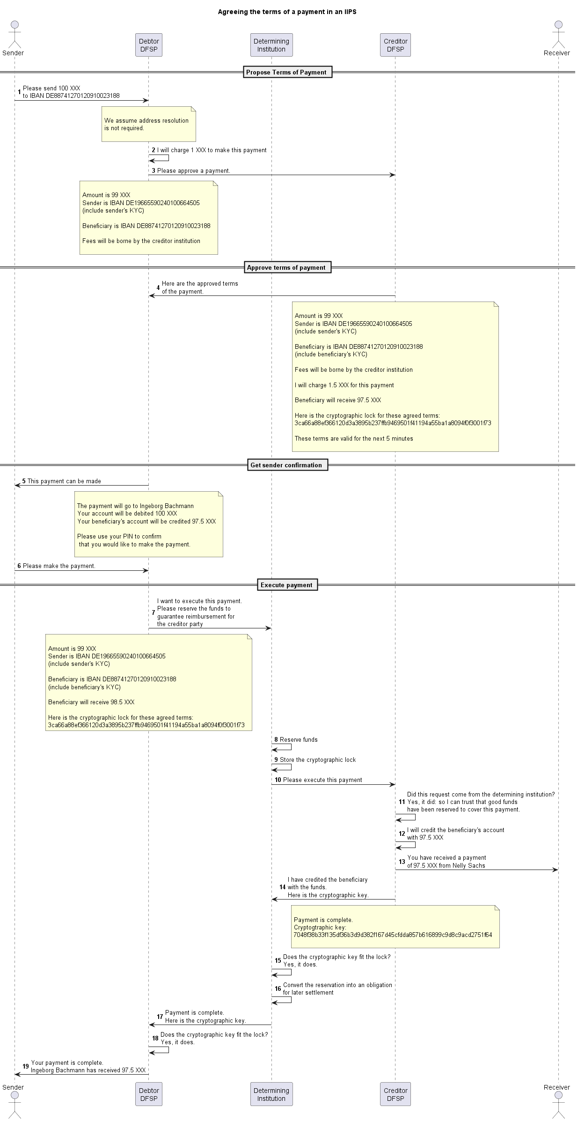

New messages

1. **Purpose of the new development:**

The Mojaloop Foundation is currently supporting the design, deployment and implementation of a regional Inclusive Instant Payments System for an organisation which represents 21 jurisdictions in Eastern and Southern Africa. One of the requirements for the regional deployment is that it should use ISO 20022 messaging for the cross-border payments. Given that another purpose of the system is that it should support merchants at the very bottom of the economic pyramid (roadside and small market traders,) it is fundamentally important that the costs of the system be reduced to a minimum. We therefore need to implement these new messages as part of this deployment.

At present, participating jurisdictions use different and mutually incompatible message syntaxes. The ability to demonstrate that ISO 20022 messages can be deployed in a low-cost, high-volume cross-border system will send a powerful message to IPS implementers in EMDE countries, and will accelerate take-up of the standard in areas where it is currently lagging.

The objectives[2] of the proposed scheme are as follows:

1. Increasing the participation of both informal and formal MSMEs[3], which are at the bottom of the financial pyramid, in inter- and intraregional trade and to give them the opportunity to capture income-generating opportunities within the region.
2. Connecting MSMEs with markets both locally and internationally through the elimination of unnecessary middlemen.
3. Increasing intra-regional trade through the formalization of MSMEs, particularly cross-border traders, small-scale farmers and women entrepreneurs into digital financial services

The driver for this initiative is a structural trade deficit for the region as a whole and the consequent need to increase cross-border trade. Since over 95% of all firms in Africa are MSMEs, although they only contribute 25% of the region’s GDP. Statistical analysis has proposed that MSMEs “have the potential to fill the gap [*between government policies on agricultural improvement and the lack of resources to implement them*] by alleviating extreme poverty among the masses, and by generating employment opportunities for the poor.”[4] The purpose of the proposed scheme is to encourage and expand the activities of MSMEs across the regions, and to enable them to participate in cross-border trade simply and effectively.

1. **Community of users and benefits:**

The initial deployment proposed for these enhancements is a regional Instant Payments System proposed by the Common Market for Eastern and Southern Africa (COMESA). The business case for this scheme is described [here](https://comesabusinesscouncil.org/wp-content/uploads/2022/02/Business-Case-for-a-Regional-Digital-Payments-Policy-for-MSMEs-in-COMESA-Executive-Summary-.-ext.pdf).

The proposal is for a scheme aligned with the principles developed by the [Level One Project](https://www.leveloneproject.org/wp-content/uploads/2020/07/L1P_Guide_2019_Final.pdf), an initiative funded by the Bill and Melinda Gates Foundation to articulate guidance and best practice for systems which promote financial inclusion in Emerging Markets and Developing Economies.

A detailed [business justification](https://comesabusinesscouncil.org/wp-content/uploads/2022/02/Business-Case-for-a-Regional-Digital-Payments-Policy-for-MSMEs-in-COMESA-Executive-Summary-.-ext.pdf) for the proposed system has been undertaken by the COMESA Business Council, the scheme’s sponsoring body. It concentrates particularly on the activities of MSMEs. It makes it clear that demand from the MSMEs for a properly functioning regional payments system exists: only 21% of respondents were using digital payments in cross-border trade, but 81% reported that they were uncomfortable using cash, and that they would prefer to use digital payments systems such as Mobile Money Systems.

The particular problems that the system is designed to address are:

* Lack of access to cost-effective cross border payment platforms which cater for the gap between what MSMES require and what banks currently provide.
* Lack of a regional integrated digital financial services infrastructure for MSMEs.
* The scarcity of data, particularly with regard to MSME cross-border flows.
* Lack of political goodwill for regional integration and harmonization.
* The fragmented legal and policy frameworks within member states and in the region as a whole. The issue of who regulates the digital financial services space especially when mobile money is put into consideration remains a major concern.
* Poor technological advancements have often resulted in some MSMEs being excluded from the payment chain due to lack of infrastructure including the network signal masts. Consequently, regional harmonization projects, such as the digital payments platform, and the use of multiple local currencies across the region, can be key drivers for scaling-up cross-border trade
* International regulations that impose strong prudential controls and operate a close to zero-tolerance to exposure to potential money-laundering and terrorist financing make it difficult for non-banking payment service providers to take part in international payments, although the MSMEs are comfortable with these platforms.
* Lack of clear AML and CFT laws in some jurisdictions make it difficult for MSMEs to access digital payment platforms.
* Lack of or failure by some jurisdictions to follow international standards in retail payment messaging often results in MSMEs being referred to the more expensive bank option.
* Country-specific data-flow barriers and data localization rules, which could either make it difficult for payment service suppliers to operate within a market or raise the cost of doing so.
* Foreign exchange controls featured as the highest barrier to international e-payments.
* Additionally, the cost and risk of currency exchange, as well as difficulties in processing wire transfers and accepting foreign credit cards have been cited as hindrances.
* More significantly, where regulations either prohibit or make it excessively expensive for an international e-payment solution to offer a service in a market, small-scale e-retailers who have global customers will rely on the costly interbank cash transfers.
* The lack of an e-commerce platform for MSME trade often results in cash on delivery transactions. These lead to costly journeys being undertaken by the traders across country borders, thus exposing women to abuse, especially at the border points.

*This section is critical. It will be used by the RMG to determine the business case and priority of the proposed development. Even if the benefits of the project may have already been described to some extent in the previous sections, submitting organisations are invited to repeat them here and to spend the time necessary to collect requested information for each of the captions below. If a caption cannot be completed, the submitting organisation is requested to explain why.*

The justification will identify the categories of parties/actors that would use/benefit from the new message(s), and **for each category of users**:

1. Benefits/savings: small traders in the region typically use informal account-holding institutions such as Mobile Money Systems, MFIs and credit unions. These institutions provide a much cheaper and better service to their customers, but they do not have access to the financial services necessary to support cross-border economic activity: in particular, access to currency conversion services. Providing access to these services via an IIPS will enable small traders to move from cash-based transactions to digital transactions, and allow them more reliable business planning and operation. Research suggests that “*A 1% increase in bilateral digital connectivity increases domestic trade by 2.1% and international trade by 1.5%. This double dividend arises in countries at all levels of development, including lower-income countries and across all sectors of the economy. There is both a domestic and an international case for growing digital connectivity*”; and, in addition, that “*a 0.1-point reduction in the domestic DSTRI (Digital Services Trade Restrictiveness Index) score is associated with a 145% increase in overall exports. The impact is highest for digitally-deliverable services but is also high in food and agriculture and manufacturing sectors. The case is even stronger for emerging economies where the benefits of reform deliver greater export gains*.”[5]
2. Adoption scenario: The adoption of the new messages will support a significant reduction in operational costs due to, first, the elimination of the need to remediate failed transactions; and, second, the automation of the provision of information used to validate the terms of the payment. In a system which is designed to support low-value payments at a cost tolerable to small account-holding institutions, it is fundamentally important to remove the costs associated with adjudicating disputes and remediating payment failures. In addition, it will reduce the amount of customers’ and FIs’ funds which are placed beyond their use while payments that will eventually fail are being executed.
3. Volumes: accurate figures in this area are not easy to come by. However, Mastercard estimates that there are 44 million MSMEs in sub-Saharan Africa overall (as of September 2023.) The same survey finds that 88% of respondents overall needed more support with digitisation.
4. Sponsors and adopters: the development of these messages is sponsored by the COMESA Business Council (CBC) CBC is the recognised Business Member Organisation of the Common Market for Eastern and Southern Africa (COMESA), a free trade area covering 21 jurisdictions. The system is being developed and implemented under the auspices of REPSS, COMESA’s Regional Payment and Settlement System.
5. **Timing and development:**

The justification will describe:

* COMESA are currently asking for bids to undertake the initial development and implementation of the system. The RFP states that the expected implementation date for the first 8 jurisdictions to go live will be November 2024; and it is a requirement of the system that ISO 20022 should be the messaging standard for the system. A delay in our ability to respond, even provisionally, to the need for these messages will increase the risk that a solution will be adopted which diverges from the preferred ISO 20022 development path.
* We expect to have these messages complete and ready for submission to the RA by the end of Q1 this year.
* We will involve:
  + CBC themselves.
  + The implementers of the proposed solution.
  + The regulators and central banks of the member states of COMESA.
  + The operators of jurisdictional IPSs for states which belong to COMESA.
  + Account-holding institutions in states which belong to COMESA.
* There are no other known standards initiative(s) involved in an effort to address the same requirements. However, once the standard is implemented, it would offer benefits to many other types of financial institution.

1. **Commitments of the submitting organisation:**

The Mojaloop Foundation commits that it can and will:

* undertake the development of the candidate ISO 20022 business and message models that it will submit to the RA for compliance review and evaluation. The submission must be compliant with the [ISO 20022 Master Rules](http://www.iso20022.org/documents/general/ISO20022_MasterRules.ZIP) and include a draft Part 1 of the Message Definition Report (MDR) compliant with the [template for MDR part 1](http://www.iso20022.org/documents/general/ISO20022_MasterRules.ZIP) submitting organization recommends to consider with the submitted message set, and, optionally, examples of valid and invalid instances of each candidate message. The submission may also include a Message User Guide (MUG) to complement the MDR and describe in further details how to use the different possibilities/options of the proposed candidate messages;
* address any queries related to the description of the models and messages as published by the RA on the ISO 20022 website.

The Mojaloop Foundation commits that it will promptly inform the RA about any changes or more accurate information about the number of candidate messages and the timing of their submission to the RA. If the submitting organisation does not submit the candidate messages within the timing announced in section F and does not inform the RA beforehand, the business justification may lapse and require re-submission of a new business justification for approval by the RMG.

The Mojaloop Foundation confirms that it intends to organize testing of the candidate messages once they have been reviewed and qualified by the RA and before their submission to the SEG(s) for approval. It is not yet known when the testing is expected to complete and the candidate messages be re-submitted to the RA for SEG(s) approval.

The Mojaloop Foundation confirms that it will promptly inform the RA about any changes or more accurate information about the timing of this re-submission to the RA. If the submitting organisation does not re-submit the candidate messages as announced and does not inform the RA beforehand, the business justification may lapse and require re-submission of a new business justification for approval by the RMG.

The Mojaloop Foundation confirms that it is committed to undertake the future message maintenance.

The Mojaloop Foundation confirms its knowledge and acceptance of the ISO 20022 Intellectual Property Rights policy for contributing organisations, as follows.

*“Organizations that contribute information to be incorporated into the ISO 20022 Repository shall keep any Intellectual Property Rights (IPR) they have on this information. A contributing organization warrants that it has sufficient rights on the contributed information to have it published in the ISO 20022 Repository through the ISO 20022 Registration Authority in accordance with the rules set in ISO 20022. To ascertain a widespread, public and uniform use of the ISO 20022 Repository information, the contributing organization grants third parties a non-exclusive, royalty-free licence to use the published information”.*

1. **Contact persons:**

The submitting organisation will provide the contact details (name, e-mail address, telephone) of the person(s) at the submitting organisation that can be contacted by the RA, RMG, SEG or SubSEG to get additional information on the project and/or its business justification.

Contact: Michael Richards

Mail address: [Michael.Richards@infitx.com](mailto:Michael.Richards@infitx.com)

Telephone: +44 7785 360009

1. **Comments from the RMG members and relevant SEG(s) or SubSEG(s) and disposition of comments by the submitting organisation:**

This section will include the comments received from RMG members and the SEG(s) or SubSEG(s), if any, and the response given to each of these comments by the submitting organisation.

1. [True-Cost-of-Failed-Payments-Global-Report-2021-1_compressed.pdf (trustyoursupplier.com)](https://trustyoursupplier.com/wp-content/uploads/2022/06/True-Cost-of-Failed-Payments-Global-Report-2021-1_compressed.pdf)
2. Source: <https://comesabusinesscouncil.org/wp-content/uploads/2022/02/Business-Case-for-a-Regional-Digital-Payments-Policy-for-MSMEs-in-COMESA-Executive-Summary-.-ext.pdf>, p.2
3. Micro, Small and Medium Enterprises
4. Bekele and Muchie: *Promoting micro, small and medium Enterprises (MSMEs) for sustainable rural Livelihood*. https://vbn.aau.dk/ws/portalfiles/portal/17023673/DIIPER_wp_11.pdf
5. Gonzales, Sorescu and Kaynak: *Of Bytes and Trade: Quantifying the Impact of Digitalisation on Trade*. OECD Trade Policy Paper 273 (https://www.oecd-ilibrary.org/docserver/11889f2a-en.pdf?expires=1706530826&id=id&accname=guest&checksum=619E07D2AC4DD226F77E2EE00EF202CE)